**LA3:** Taking care of myself for proper growth and development

**LOI**

Caring for my eyes.

**Competence:**

Cares for and protects his / her eyes

**Materials** – Visual aids

* Real objects

**Procedure:**

* Let the teacher introduce the lesson with a song

Head , shoulders, knees and toes x2

* Let the teacher show flash cards of eyes
* Let the learners identify the part of the body (eyes)

**Activity**

Shade the eyes

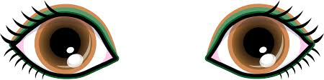

**LESSON 2 AND 3**

**Procedure:**

* Let the teacher introduce the lesson with a song.
* Let the teacher demonstrate how we care and protect the eyes.
* Let the learner identify the things we use to care and protect the eyes.

**Materials** : Real objects

* Water - soap - towel

**Activity:**

* Shade the things we use to clean our eyes.
* Match the same

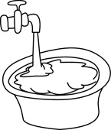 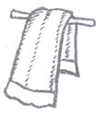

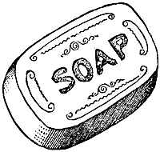 

 

**LESSON 4**

**Activity:**

Things that harm the eyes

**Materials –** Visual aids

* Flash cards

Shade the things that harm our eyes.

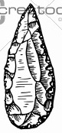 BD04915_ NA00809_

**LO II**

Caring for my ears

**Competence:**

Protects and cares for the ears.

**Materials**: - visual

* Flash cards

**Procedures**

* Start with a rhyme

Parts ---parts of my body x 2

Ears are parts of, parts of my body x 2

**Activity:**

Shade the ears.

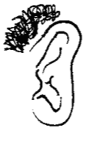 

**LESSON 3**

**Ears**

How to care for my ears

* By washing ears through teacher’s guidance
* By cleaning using ear buds.

**Rhyme**

Oh what a wonderful gift

That God gave me

Oh my ear, I use my ear

To hear, that’s why I keep

them clean

**Activity:**

Trace the ears



**LO III**

Using the senses of touching and feeling to describe things and situations

**Competence:**

Differentiates between temperatures and reacts verbally in an appropriate manner.

**Materials:** - real objects

* Water, sand, clay, stone, seeds, cotton, cloth, wall.
* Chart showing things my hands can do

**Procedure:**

Start with a rhyme

‘A pot for water

A pot for cooking

Big or small

There all pots

* Playing with and mixing water of different temperatures (cold, warm, hot)

**Activity**

Provide water of different temperatures i.e warm, cold

**Activity 2**

Colour the drinks we take on sunny days

 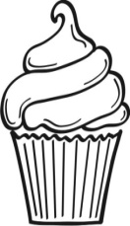 Description: C:\Documents and Settings\esther\Local Settings\Temporary Internet Files\Content.IE5\XS5NRJF0\MC900264358[1].wmf 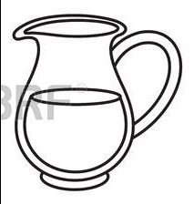

**Activity 3**

Tell and colour the things we wear on a sunny day.

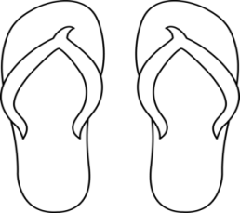 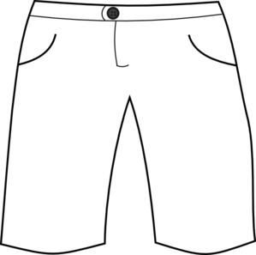 

**Activity 4**

Telling and matching the things we wear on a cold day

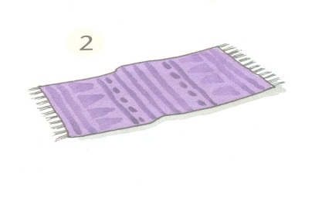 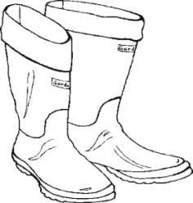

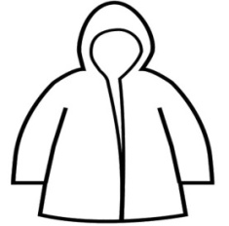 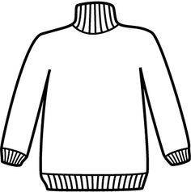

 

 

**Activity 5**

Colour what makes things cold

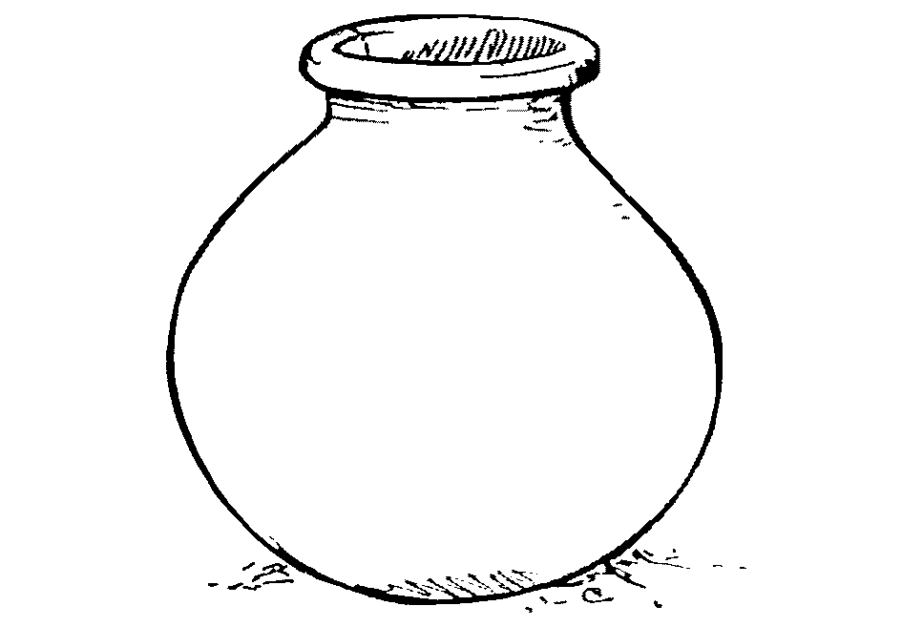 j0293828 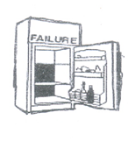

**Activity**

Shade what makes things warm

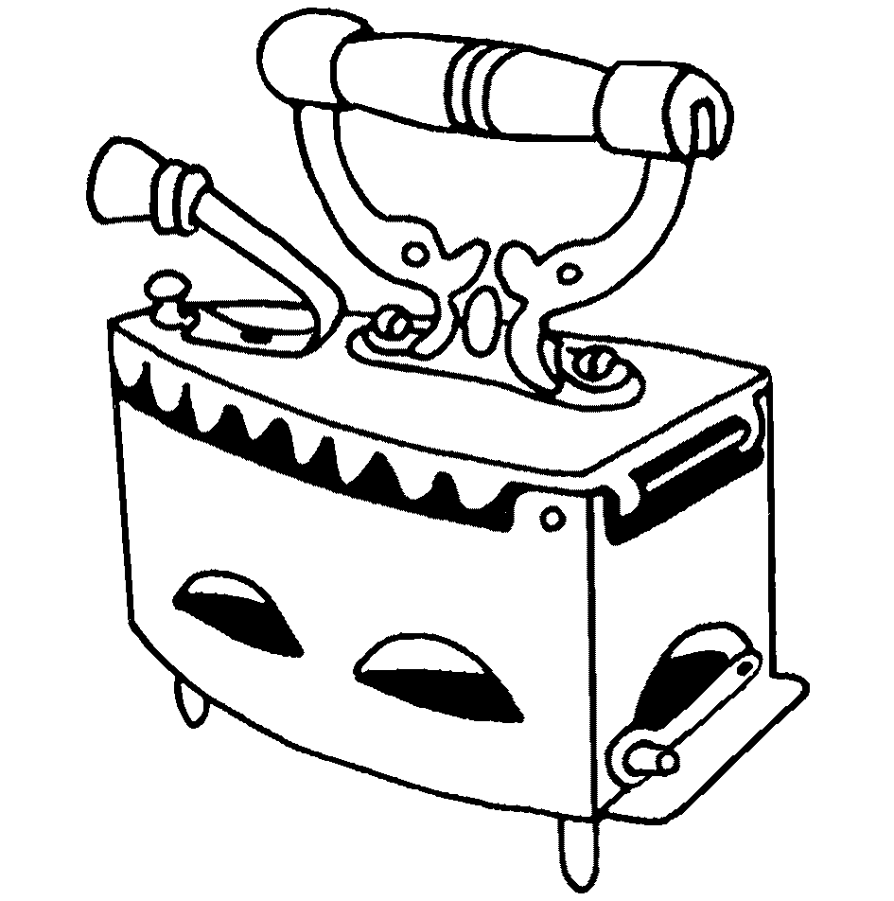 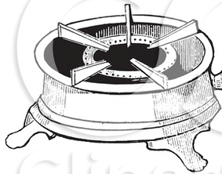

**LO IV**

Caring for my body

**Competence:**

Protects and cares for his / her body

Naming different parts of the body orally.

**Materials:** - visual aids

* Real objects (person)

**Procedure:**

* Let the lesson start with a rhyme / song

Head, shoulders, knees and toes

* Show flash cards of the body
* Identify the parts of the body.

**Activity:**

Ask learners to show you these body parts as you revise the senses.

Shade the body

**Lesson 2 and 3**

Trace the body parts.

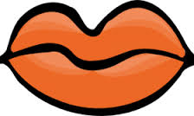 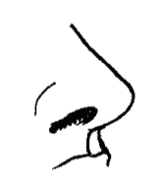  

**Activity 4**

**Match the body parts**

 

 

 

 

**Activity 5**

**Put what is missing**

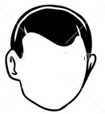

**LESSON 6**

**Procedure:**

* Start with a rhyme / song

Oh what a wonderful gift

That God gave me

Oh my ear I use my ear to hear

That’s why I keep them clean

* Show flash cards of things we use to clean our body.
* Identify the things we use to clean our body.

**Materials:** - Real objects

* Flash cards
* Visual aids

**Activity:**

Match the same body parts

 

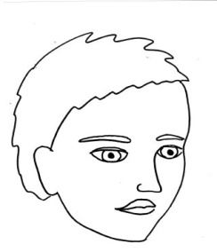 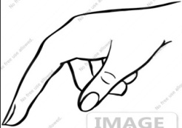

 

 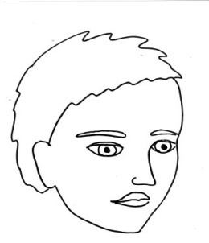

 

**LESSON 7**

**Materials:** - visual aids

* Flash cards

**Procedure:**

* Start with a rhyme or a song
* Show flash cards of things that harm our body
* Let the learner identify the dangerous things to our body.

**Activity:**

Colour the dangerous objects / things that harm our body

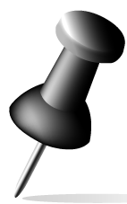 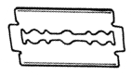 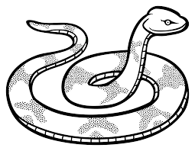 MC900112970[1]

**Activity 8**

Match the things we wear.

  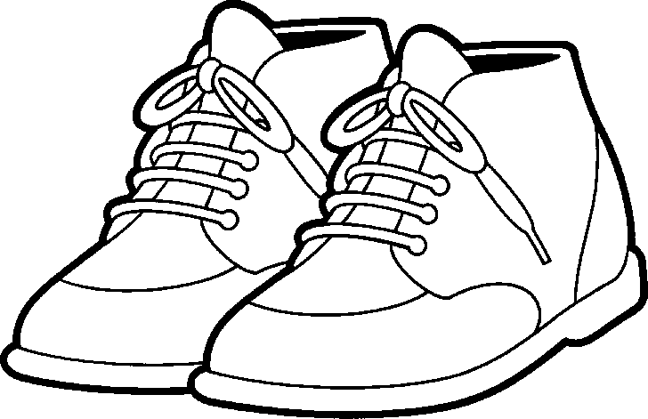 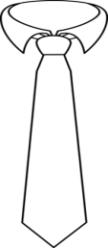

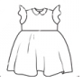 

 

 

**LOVI**

Using the sense of test and caring for the mouth

**Competence:**

Protects and cares for his / her mouth

**Materials:** - flash cards

* Real mouth

**Procedure:**

* Teacher will start with a song

My eyes are white and black

My lips are red

* Will show the flash cards.
* Pupils will identify

**Activity 1:**

Shade the mouth



**Activity 2:**

Trace the parts of the mouth

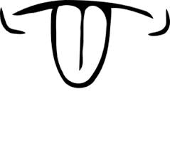 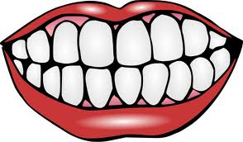

**Activity 3:**

Match the things used to clean the mouth

 Description: C:\Documents and Settings\esther\Local Settings\Temporary Internet Files\Content.IE5\XS5NRJF0\MC900371086[1].wmf

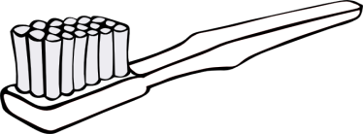 

Description: C:\Documents and Settings\esther\Local Settings\Temporary Internet Files\Content.IE5\XS5NRJF0\MC900371086[1].wmf 

**Activity 4:**

Practicing how to care for the mouth

**L.O.VIII**

Identifying and naming different body parts and their uses.

**Competence:**

Names activities that his / her body parts can perform

**Materials:** - Real body parts

**Procedure:**

* Teacher will start with a song

Clap x 2 I like it

Wave x 2 I like it

Dance x 2 I like it

* Teacher will demonstrate the activities done by the body parts.
* Learner will imitate after the teacher.

**Activity 1**

Learners will do the activities practically.

Clapping, dancing, writing, washing, sweeping, nodding

**Activity 2:**

Match the same activities my hands can do

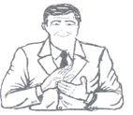 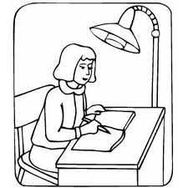

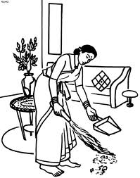 Description: C:\Users\waps\AppData\Local\Microsoft\Windows\Temporary Internet Files\Content.IE5\ROEC6EH3\MC900440562[1].wmf

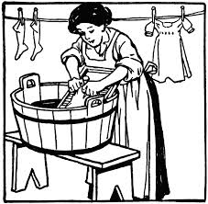 

Description: C:\Users\waps\AppData\Local\Microsoft\Windows\Temporary Internet Files\Content.IE5\ROEC6EH3\MC900440562[1].wmf 

 

**Activity 3:**

Complete by putting on the hands

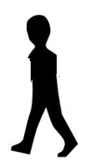 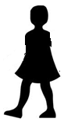

**Activity 4:**

Making patterns with our finger prints with different colours from leaves, flowers, anthill soil etc

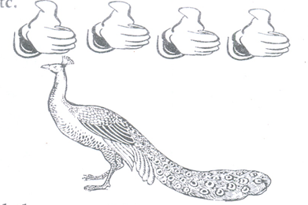

**LOX**Expressing creativity freely and independently

**Competence:**

Appreciates and takes care of materials made by God, people and him / herself

**Materials:** - Visual

* Real objects like sun, trees and animals

**Procedure:**

* Teacher will introduce the lesson with a song

“Who made you and me

You and me x 2

Our father God.

* Teacher will show flash cards
* Learner will identify the things made by God.

**Activity 1**

Shade things made by God.

NA00809_

**LESSON 2:**

Trace things God made

BD07846_ 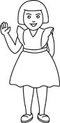 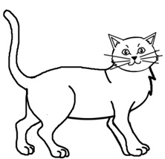

**LESSON 3**

Match the same things God created.

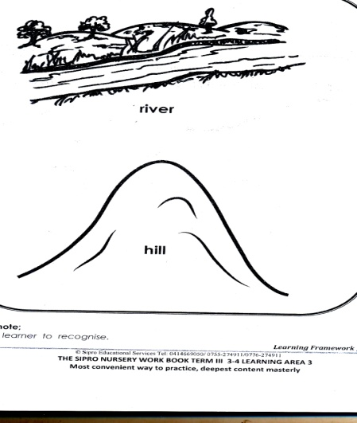

NA00809_

BD07846_



NA00809_ BD07846_

**LESSON 4:**

Draw the same

NA00809_

Things created by man.

**Materials**: - flash cards,

* Real objects

**Procedure:**

* Teacher will introduce the lesson with a song

Cup x 3

I love my cup

A cup is nice for taking tea

* Teacher will show the flash cards
* Learner will identify things made by man

**Activity 1**

Circle the same

HH01672_ SL01040_ SL01040_

**LESSON 2 AND 3**

Complete

 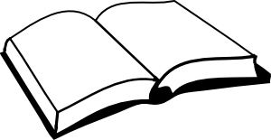

**LESSON 4**

Copy and draw

|  |  |  |  |
| --- | --- | --- | --- |
| HH01672_ |  | SL01040_ |  |

**L.O IX:**

Keeping healthy and practicing good health habits

**Competence:**

Practices good eating habits

**Materials: -** real objects like tap, food, fingers, plates

**Procedure:**

* Teacher will start with a prayer

Humble yourself

Dear Lord, bless our food and our drinks, which we are going to eat Amen.

**LESSON 1**

Learners will practice the prayer with the help of the teacher.

**LESSON 2**

Shade a baby eating food.

**LESSON 3**

Practice washing the hands.

**LESSON 4**

Learning good eating habits like, washing hands, praying, thanking, cleaning after eating etc

**LESSON 5**

Things we use to eat food

Shade

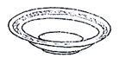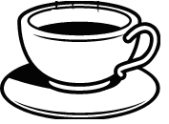 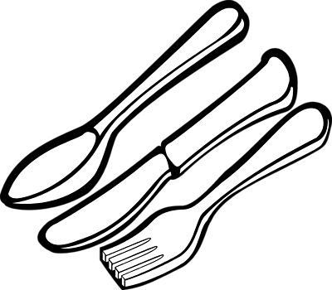

**LESSON 6:**

Match the same

 

 



 



**L.O.XII**

Keeping safe and avoiding accidents.

**Competence:**

Tells dangerous situations, e.g falling down, drowning in a pool, being knocked by a car, shocked by electricity

**Materials:** flash cards.

* Charts
* Visual aids

**LESSON 1**

Imitating and role play

**LESSON 2:**

Colour dangerous situations

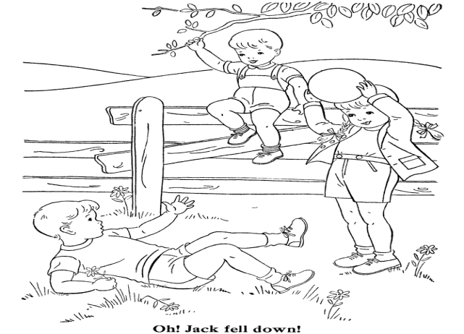 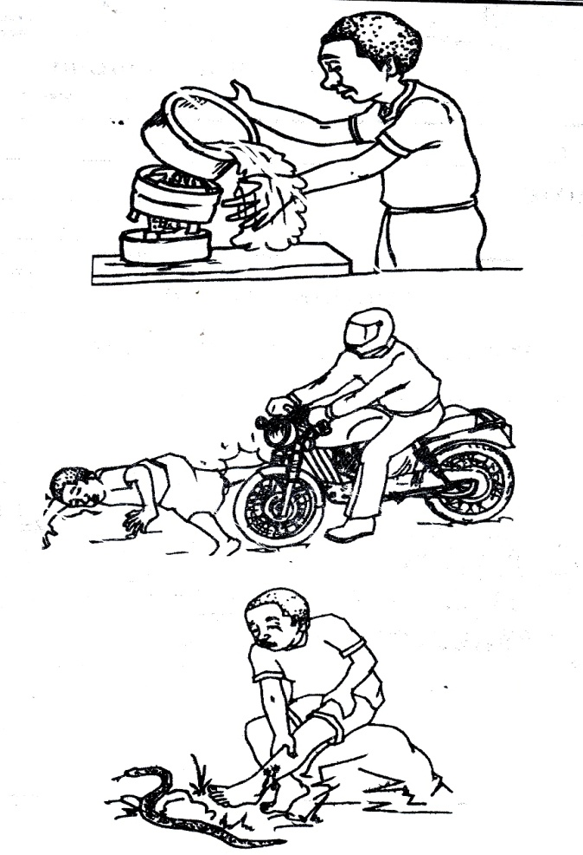

**LESSON 3:**

Knocked by a car drowning in water

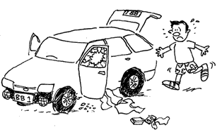 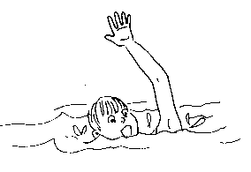

**LESSON 4:**

Review lesson 2 and 3

Activity;

Match the same

 

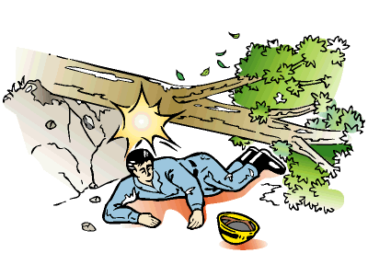 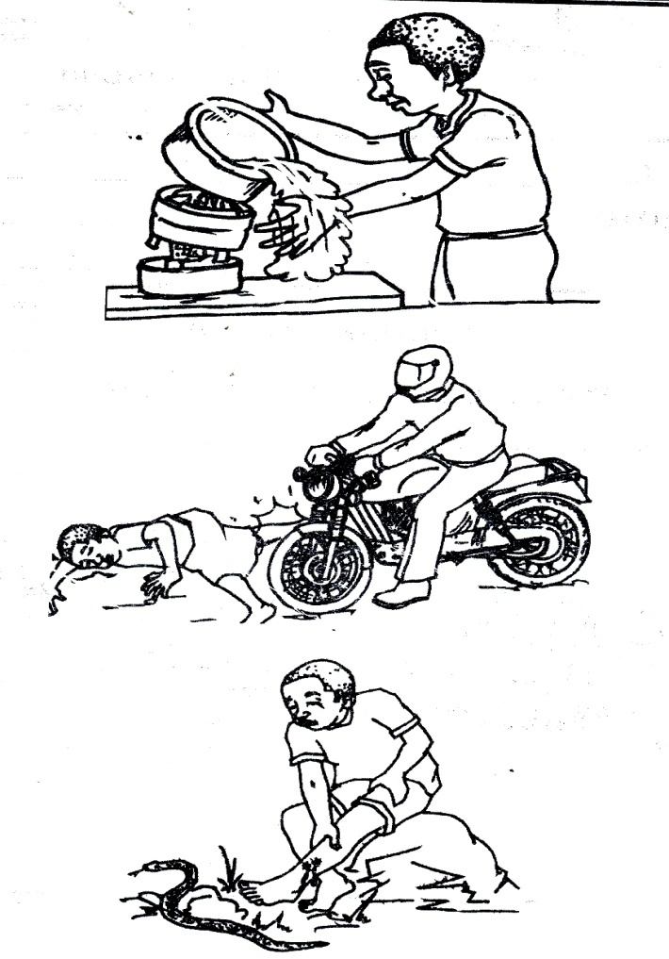

 





**MORE PRACTICE WORK**

**LEARNING AREA 3 (HEALTH HABITS)**

**Body parts**

**Naming body parts orally**

Shading

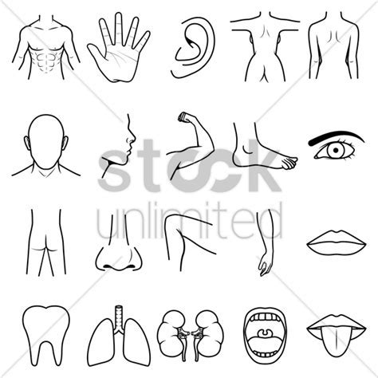

Shade

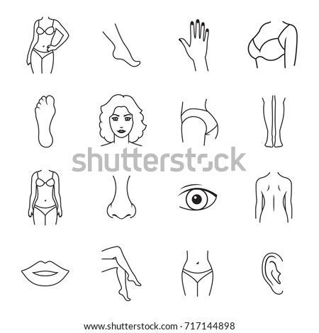

**Naming body parts orally**

Trace



Trace



**Matching the body parts**

 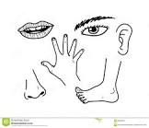

 

 

**Match correctly**

 

 

 

**TOPIC**

**THINGS WE USE TO CLEAN OUR BODY**

Shade a tooth brush

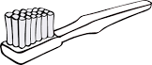

Shade a towel

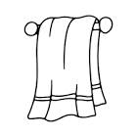

**Tracing**

**Trace a comb**



Trace a razorblade



Trace toothpaste



**MATCHING THINGS WE USE TO CLEAN OUR BODY**

**Match the same**

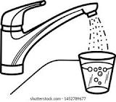 

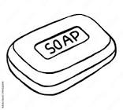 

 

**Naming things we use to clean our body orally**

**Match correctly**

 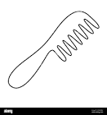

 

 

**Naming them correctly**

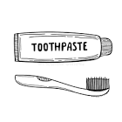 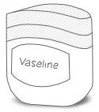

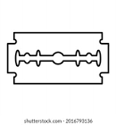 

 

**TOPIC**

**FRUITS**

**CONTENT**

**Naming fruits orally**

Mango orange apple pineapple yellow banana pawpaw watermelon sugarcane jack fruit

**CONTENT**

**SHADING THE FRUITS**

Shade an apple

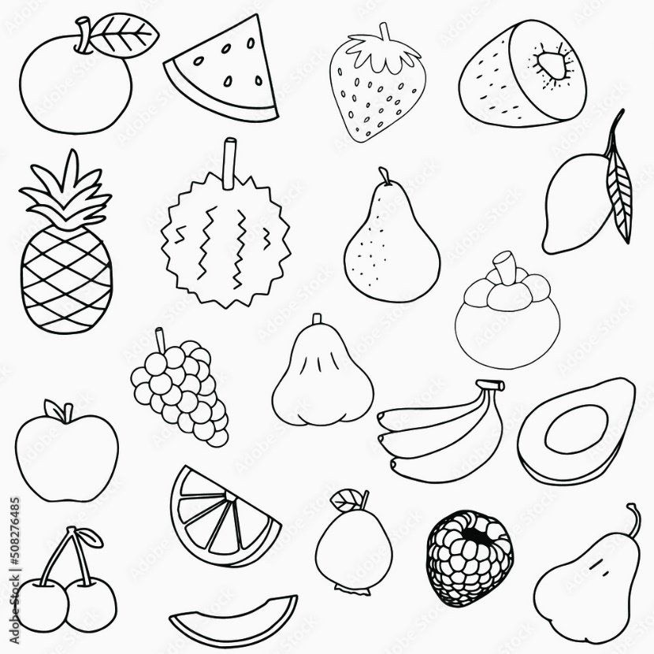

**Naming the fruits orally**

Shade a yellow banana

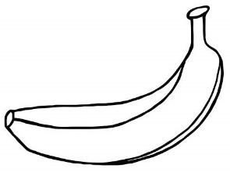

Shade an orange

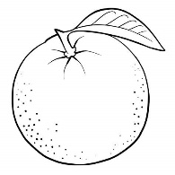

Shade a pineapple

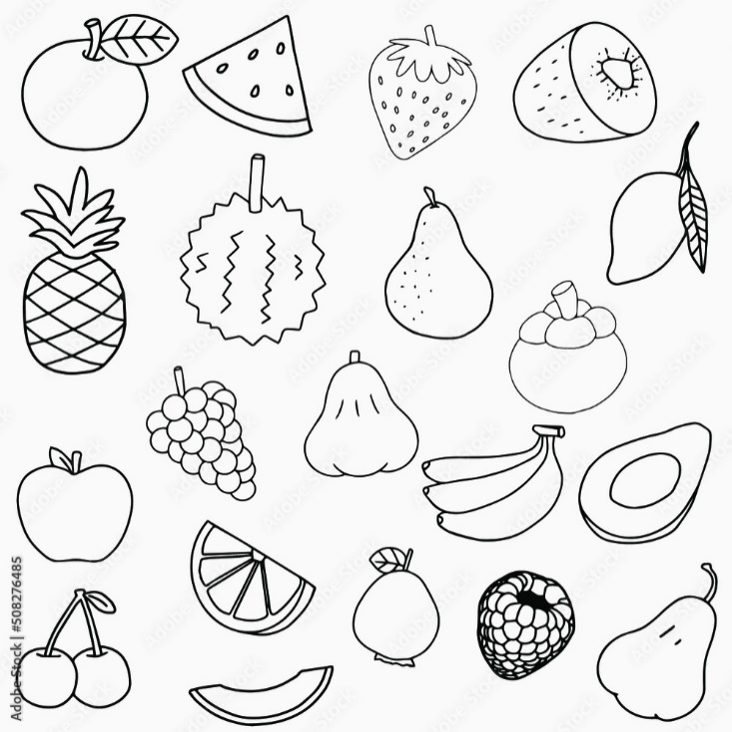

Shade a pawpaw

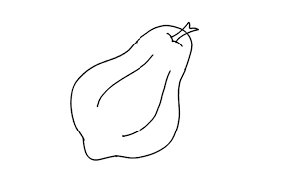

**Tracing the fruits**

Trace a sugarcane



Trace a watermelon



**MATCHING FRUITS**

**Match the same fruits**

 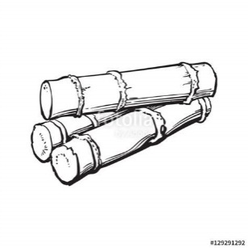

 

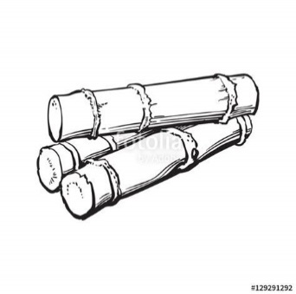 

**Match**

